

**Costa Rica**

**Untamed Costa Rica**

San Jose- Corcovado - Puerto Jimenez, Lapa Rios Reserve

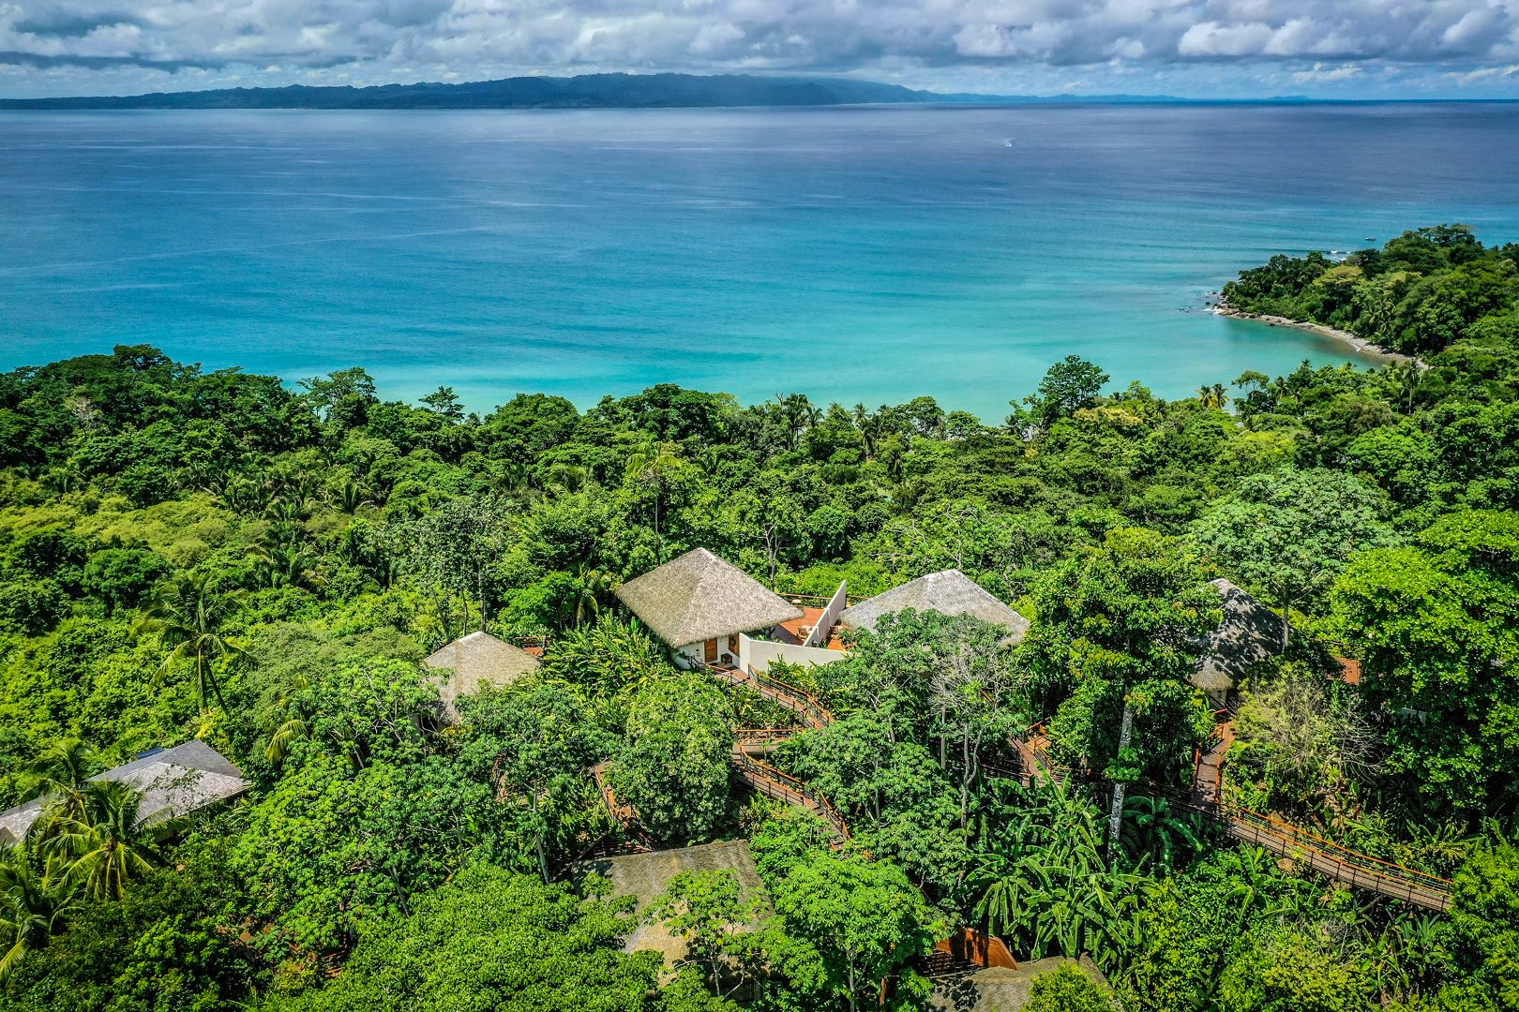

|  |  |  |
| --- | --- | --- |
| BEST SEASON | PRICE | HOW LONG |
| All year | From US $4,900 pp including local flights | 8 Days / 7 Nights |
|  |  |  |

ITINERARY OVERVIEW

Discover the ultimate luxury family vacation in Costa Rica with this exclusive 7-night adventure through the country's most secluded and biodiverse regions. Begin in San José before venturing into the world-renowned Corcovado National Park, hailed by National Geographic as the most biodiverse place on Earth. Stay at the luxurious Copa de Arbol Beach & Rainforest Resort, where you’ll snorkel around the pristine Caño Island and unwind in a tropical paradise. Continue to the 5-star eco-luxury Lapa Rios Lodge on the Osa Peninsula, which protects 1,000 acres of Central America’s last remaining tropical lowland rainforest. Here, rainforest treks, private guided tours, and incredible wildlife encounters await. From spotting sea turtles and dolphins to hiking hidden waterfalls, this journey offers an unparalleled blend of adventure, nature, and luxury—perfect for discerning travelers seeking a unique and enriching Costa Rican experience beyond the typical tourist routes.

**Quick Summary**

B: Breakfast L: Lunch D: Dinner OV: Overnight

|  |  |  |
| --- | --- | --- |
| **Day & Location** | **Transportation, Highlights and Accommodations** | **Meals** |
| Day 1  **San Jose** | Arrival Trasfer. Free day in San Jose city.  **OV: Costa Rica Marriott Hotel Hacienda Belen** |  |
| Day 2  **Corcovado** | Flight from San Jose to Drake Bay. Boat transfer**.**  **OV: Copa de Árbol or Similar** | BLD |
| Day 3  **Corcovado** | Caño Island  **OV: Copa de Árbol or Similar** | BLD |
| Day 4  **Corcovado** | Corcovado National Park  **OV: Copa de Árbol or Similar** | BLD |
| Day 5  **Puerto Jimenez** | Flight from Drake Bay to Puerto Jimenez.  **OV: Lapa Rios** | BLD |
| Day 6  **Puerto Jimenez** | Guided activities at Lapa Rios  **OV: Lapa Rios** | BLD |
| Day 7  **Puerto Jimenez** | Guided activities at Lapa Rios  **OV: Lapa Rios** | BLD |
| Day 8  **Departure** | Transfer to Puerto Jimenez airstrip for a local flight back to San Jose (included), connect with your International flight (not included) | B |

ITINERARY IN DETAIL

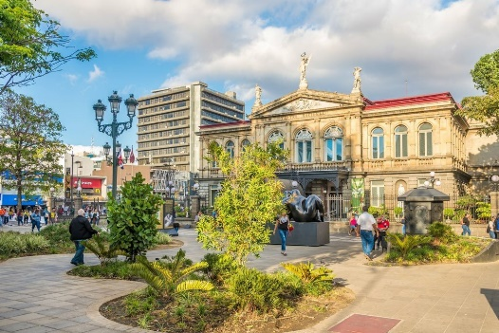**Day 1 | Arrival in San José**

Your exciting Costa Rican adventure begins the moment you arrive at Juan Santamaría International Airport. After disembarking, follow the signs to the immigration area where your passport will be checked and stamped. Collect your luggage from the baggage claim and proceed through customs by placing your bags on the conveyor belt for X-ray screening. With your documentation in hand, you’re ready to exit the airport. Avoid unsolicited taxi offers by scanning the area for your Green Planet Expeditions (GPE) representative, who will ensure a smooth transition to your hotel. Settle into your comfortable accommodation at Hotel Costa Rica Marriott Hotel Hacienda Belen. Enjoy a relaxing evening in San José, exploring the vibrant city or simply unwinding at the hotel. Overnight Costa Rica Marriott Hotel Hacienda Belen.

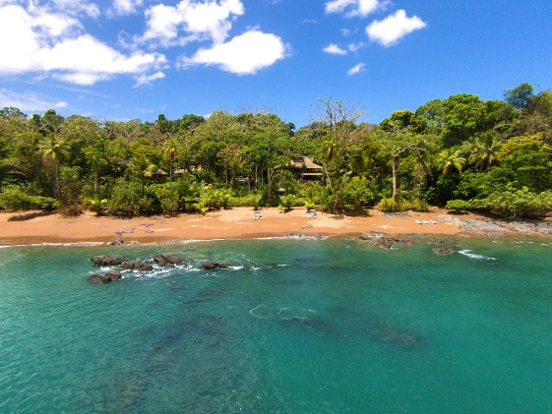**Day 2 | San José to Corcovado**

Begin your incredible journey with an early breakfast at Hotel Costa Rica Marriott Hotel Hacienda Belen. A dedicated GPE driver will pick you up from your hotel and transfer you to the domestic flight terminal at Juan Santamaría International Airport. From here, you’ll board a flight to Drake Bay, the gateway to the pristine wilderness of Corcovado National Park. The flight offers stunning aerial views of Costa Rica’s diverse landscapes, from lush mountains to expansive coastlines. Upon arrival in Drake Bay, your adventure continues with a scenic boat ride across serene waters to reach Copa de Arbol Beach & Rainforest Resort. As you glide through the emerald waters, keep an eye out for dolphins and marine birds that often accompany the boat. At Copa de Arbol, you will be greeted with a refreshing welcome drink and shown to your luxurious accommodations nestled amidst the rainforest. The resort’s exclusive setting offers unparalleled views of the ocean and the surrounding tropical landscape. After settling in, enjoy a sumptuous lunch prepared with fresh, local ingredients, showcasing the vibrant flavors of Costa Rican cuisine. The afternoon is yours to relax and explore the resort's amenities, including private beaches, hiking trails, and the inviting natural swimming pool. In the evening, savor a gourmet dinner crafted by the resort’s talented chefs. The menu features a fusion of local and international dishes, ensuring a delightful dining experience. With your dedicated naturalist guide on hand for the next day’s activities, your Costa Rican odyssey is off to an extraordinary start. Overnight at Copa de Arbol Beach & Rainforest Resort.

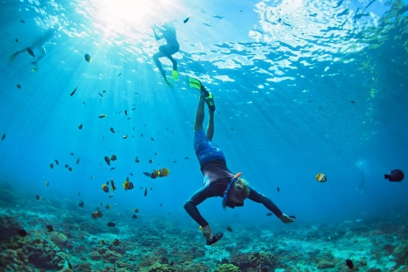**Day 3 | Discovering the Wonders of Caño Island**

Awake to the sounds of the rainforest and the gentle waves lapping at the shore. After a delightful breakfast at Copa de Arbol Beach & Rainforest Resort, prepare for a day of exploration and wonder as you embark on a journey to Caño Island Biological Reserve, a true gem of Costa Rica’s Pacific coast. A private boat will whisk you away from the resort to the stunning Caño Island. As you navigate through the turquoise waters, your naturalist guide will provide insights into the marine and terrestrial ecosystems that make this region so special. The reserve, known for its rich biodiversity and pristine beauty, is a sanctuary for a wide variety of wildlife. Upon arrival, you'll be greeted by lush tropical forest and beautiful white-sand beaches. The island is renowned for its remarkable snorkeling opportunities, and you'll have the chance to explore vibrant coral reefs teeming with colorful marine life. The waters around Caño Island are home to a diverse array of species, including sea turtles, rays, and schools of tropical fish. Your guide will ensure you have a front-row seat to witness these underwater marvels. For those interested in history, Caño Island also boasts impressive pre-Columbian stone spheres, believed to have been created by ancient indigenous cultures. Your guide will share fascinating stories about these enigmatic artifacts and their significance to Costa Rican heritage. After a morning of snorkeling and exploring, enjoy a delicious picnic lunch on the island, prepared with fresh, local ingredients. Relax on the sandy shores or take a leisurely swim in the crystal-clear waters. In the afternoon, return to Copa de Arbol for some well-deserved relaxation. You might choose to unwind in the resort’s natural swimming pool, take a gentle stroll along the beach, or simply soak in the stunning views from your private terrace. As the sun begins to set, gather for an exquisite dinner at the resort, featuring a selection of gourmet dishes that highlight the best of Costa Rican cuisine. The evening is yours to savor the tranquility of the resort and reflect on the day’s adventures. Overnight at Copa de Arbol Beach & Rainforest Resort.

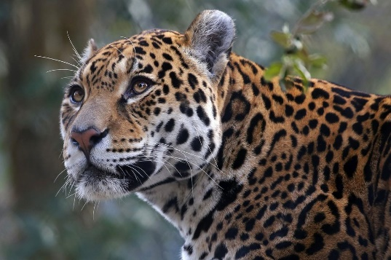**Day 4 | Immersed in the Wonders of Corcovado National Park**

Awaken to the chorus of the rainforest as the morning sun filters through the dense canopy. After a hearty breakfast at Copa de Arbol Beach & Rainforest Resort, get ready for an unforgettable adventure into one of the most biodiverse places on the planet: Corcovado National Park. Today, you’ll embark on a guided expedition into this sprawling wilderness, renowned for its incredible natural beauty and abundant wildlife. Corcovado National Park covers nearly 165,000 acres of pristine tropical rainforest and is considered one of the most biologically intense places on Earth. A boat will transport you from the resort to the park’s designated entrance, where you’ll meet your expert naturalist guide. Your guide, equipped with in-depth knowledge and a passion for conservation, will lead you through the park's varied ecosystems, from lush rainforests and mangrove swamps to sandy beaches and freshwater streams. As you journey deeper into the park, keep your eyes peeled for the incredible array of wildlife that calls Corcovado home. The park is a sanctuary for elusive species such as the jaguar, Baird’s tapir, and the endangered harpy eagle. You might also encounter playful spider monkeys swinging through the treetops, vibrant toucans flitting among the foliage, and the occasional elusive ocelot. Your guide will point out and explain the park’s unique flora, including towering ceiba trees, vibrant orchids, and rare medicinal plants. Learn about the intricate balance of this ecosystem and the conservation efforts dedicated to preserving it. During your exploration, you’ll stop at a picturesque beach within the park, where you can relax and enjoy a delicious picnic lunch amidst breathtaking surroundings. The pristine coastline here is a perfect spot to unwind and take in the natural beauty of the Pacific Ocean meeting the rainforest. After lunch, continue your trek through Corcovado, venturing into lesser-known trails that showcase the park's hidden treasures. Discover serene waterfalls, tranquil riverbanks, and dense forest groves as you immerse yourself in the sights and sounds of this untouched paradise. As the day winds down, return to Copa de Arbol Beach & Rainforest Resort by boat, where you can relax and reflect on the day's remarkable experiences. Enjoy a sumptuous dinner featuring fresh, locally sourced ingredients, and unwind with a view of the sunset over the lush rainforest. Overnight at Copa de Arbol Beach & Rainforest Resort.

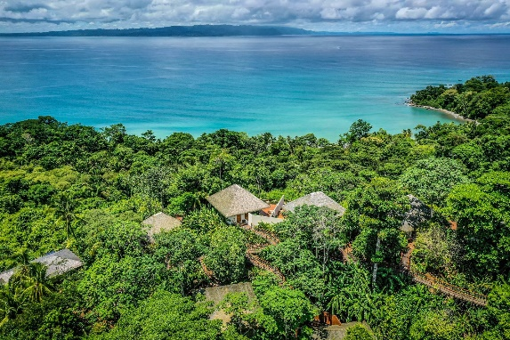**Day 5 | From Drake Bay to Puerto Jiménez – The Journey to Lapa Rios Lodge**

Begin your day with a sumptuous breakfast at Copa de Arbol, savoring the serene moments in this rainforest haven. The resort’s attentive staff will assist with your departure, arranging a scenic boat transfer to the Drake Bay airstrip. This peaceful boat ride offers one last opportunity to immerse yourself in the lush beauty of the Osa Peninsula, where wildlife such as caimans and monkeys might make an appearance along the pristine waterways. Upon arriving at the airstrip, you'll check in for your flight to Puerto Jiménez. The 20-minute domestic flight provides spectacular aerial views of Costa Rica’s diverse landscapes, from verdant rainforests to winding rivers and rugged coastlines, marking a picturesque transition to your next adventure. Land in Puerto Jimenez, where a Lapa Rios representative will meet you privately on the tarmac, assist with luggage and transfer you in a private 4WD vehicle to Lapa Rios Lodge, at the end of the wild Osa where the rainforest meets the sea. Welcome to a vivid landscape that National Geographic has deemed “the most biologically intense” place on the planet, where macaws screech & soar, monkeys chatter and humpback whales splash in the Gollfo Dulce. Luggage will be transferred to your room while you enjoy lunch, selecting from tacos and ceviche featuring freshly caught fish, light gazpachos, an array of delicious salads and more. Take some time to relax by the pool or in your villa, observing the abundance of wildlife all around you. You’ll reconnect with your private guide before dinner to discuss your activities and excursions over the next few days or begin your explorations with a nocturnal walk through the forest in search of creatures most active and visible at night. Overnight a Lapa Rios Lodge.

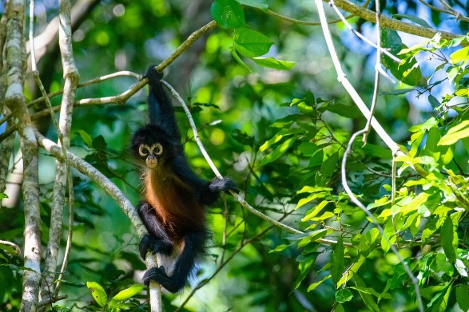**Day 6 & 7 | Lapa Rios**

Lapa Rios Lodge protects a 1,000-acre private rainforest reserve, encompassing primary and secondary forest that provides a critical corridor for wildlife moving between the borders of the Osa Peninsula’s many national parks and preserves. Accompanied by expert naturalist guides, guests discover the magic of the Pacific Coastal tropical rainforest and Golfo Dulce, one of just four tropical fjords in the world and a favorite habitat of sea turtles, dolphins and whales. Below Lapa Rios, the beaches are a haven for surfers, offering three perfect point breaks ideal for a range of abilities. Guests will be privately guided throughout their time at Lapa Rios and will work with their guide to select from eight different guided excursions through the forest and along the beaches. Splash through a river canyon on our Wild Waterfalls Hike, discover the medicinal properties of rainforest plant, visit the local Carbonera School and join the students in a soccer match or search for wildlife as you hike through palm forests, primary & secondary rainforest on the Osa Trail. Guests may also select from an assortment of adventures (such as surfing, kayaking in the mangroves or through bioluminescence, horseback riding, boat excursions to spot dolphins and whales in Gulfo Dulce and more) that are operated on a private basis by vetted outside partners. These excursions are available for an additional fee. Overnight at Lapa Rios Lodge.

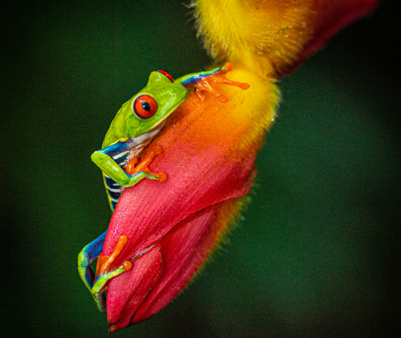**Day 8 | Return to San José and Departure**

Conclude your Costa Rican adventure with a transfer back to Puerto Jiménez for your flight to San José. Once in San José, a GPE representative will assist with your final journey to Juan Santamaría International Airport. Ensure you arrive at the airport at least three hours before your departure to facilitate a smooth check-in process. Safe travel! **Safe travels** and we hope to welcome you back to Costa Rica soon!

**Important note:** To facilitate a seamless connection with your local flight, it is crucial that your international flight departs no earlier than 11:00 a.m. If your international flight is scheduled to depart earlier, we recommend planning an overnight stay in San Jose city on day 8 and departing at your convenience on day 9 to ensure a hassle-free continuation of your journey.

.

**Pricing**

|  |  |  |
| --- | --- | --- |
| **2025** | **Per Adult Sharing double occupancy** | **Per Children (3 to 12)** |
| Price based on 4 travelers | $4,900 | $4,650 |

*This is a preliminary costing; hotels may vary according to availability at time of booking.*

**Included**

* All guided tours and excursions mentioned
* Land Airport-hotel transfers
* Local flights
* Boat transfers
* Meals as indicated [B-Breakfast, L-Lunch, D-Dinner]
* All entrance fees to the sites mentioned in the above itinerary
* Hotel accommodation as mentioned in the itinerary
* Permanent assistance during the trip
* Green Planet Expeditions travel consultation and pre-departure services

**Not included**

* International airfares
* Tips and gratuities
* Airport departure taxes
* Drinks, alcoholic beverages, and meals other than listed above.
* Personal expenses for extra services, optional activities, or changes in your itinerary for reasons beyond our control
* Mandatory Travel Insurance: To ensure a smooth travel experience, all participants are required to have a comprehensive travel insurance policy. This policy should include trip cancellation, medical services, and coverage for active adventures or evacuations. “Cancel For Any Reason” (CFAR) coverage is highly recommended to protect your investment in case of unforeseen circumstances.
* Any other items not mentioned above

**ACCOMMODATIONS**

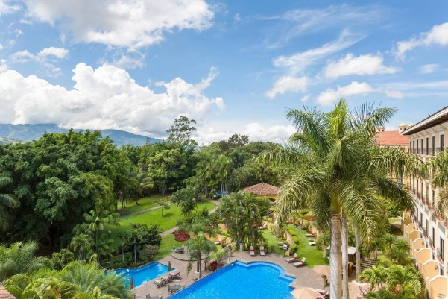**Costa Rica Marriott Hotel Hacienda Belen**

Costa Rica Marriott Hotel Hacienda Belén is a stunning colonial-style retreat set on a 12-hectare coffee plantation, blending historic charm with modern luxury. The resort features elegant rooms with flat-screen TVs, luxurious toiletries, and select accommodation offering tranquil pool views, all designed for comfort and sophistication. Dining is an elevated experience, with La Isabella offering refined Peruvian-inspired cuisine, Antigua showcasing vibrant Latin American flavors, and the café serving world-class Costa Rican gourmet coffee. Conveniently located just 5 km from Juan Santamaría International Airport, this property offers an unmatched combination of elegance, heritage, and first-class service.

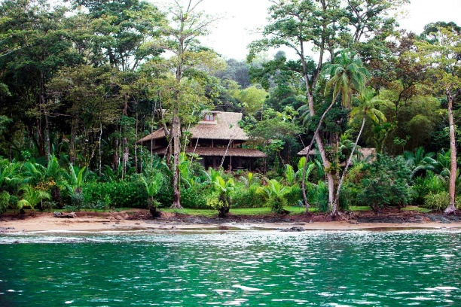**Hotel Copa de Arbol**

Copa de Arbol Beach & Rainforest Resort is an exclusive eco-luxury retreat located on the untouched shores of Costa Rica’s Osa Peninsula, offering a seamless blend of wilderness and comfort. Hidden between lush rainforest and sparkling beaches, this resort invites guests to stay in beautifully crafted, open-air tree-house-style bungalows with breathtaking ocean views. Immerse yourself in the natural beauty of Corcovado, where wildlife roams free and adventure awaits at every turn. From guided rainforest hikes to snorkeling at Caño Island’s vibrant coral reefs, Copa de Arbol delivers a truly unforgettable escape in one of the most biodiverse places on Earth.

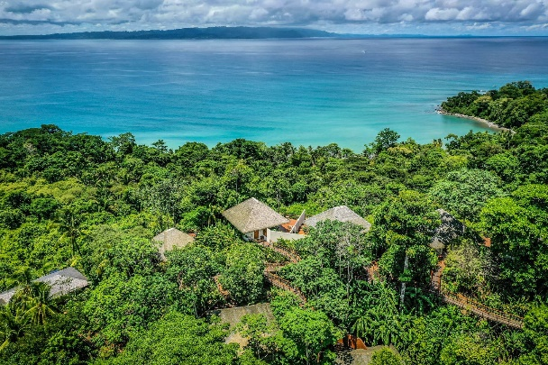**Lapa Rios**

Lapa Rios Lodge in Puerto Jiménez is a world-class eco-luxury retreat set in a private 1,000-acre rainforest reserve on the Osa Peninsula, where the lush jungle meets the turquoise waters of the Pacific. Offering breathtaking ocean views from every bungalow, the lodge immerses guests in nature without sacrificing comfort. Wake up to the calls of scarlet macaws and monkeys, explore the rainforest with expert naturalist guides, and relax in your open-air bungalow, designed to blend seamlessly into the surroundings. At Lapa Rios, every moment is a connection with Costa Rica’s incredible biodiversity, providing an exclusive, sustainable experience in one of the planet’s most wild and unspoiled regions.

**Booking your Green Planet Expedition**

**How to reserve a trip**

To secure your spot on a trip, you can conveniently book online using our [Reserve a Trip form](https://greenplanetexpeditions.com/reservation-form/)  or by calling **1-800-430-9498**. Your reservation is confirmed upon receipt of the reservation form and the initial 50% trip deposit.

Please note that we are unable to hold space until the deposit is received. If the requested space is unavailable, we will promptly provide alternative options for your consideration (if an upgrade is necessary, higher rates may apply).

**Pre departure service**

Upon receipt of your deposit and completed reservation form, we will email you a comprehensive Predeparture Dossier. This contains important information to help you prepare including immunizations, visas, trip insurance, packing checklist, reading list, maps, cross-cultural information, optional trip extensions, and more. You will receive a final trip email including Final Reminders and local contact information in your destination 2-3 weeks before departure.

**Terms and Conditions**

Green Planet Expeditions has arranged your trip utilizing the travel services of local in-country ground operators who are independent contractors. These local outfitters, lodges, hotels, and other suppliers of your travel services will make every effort to conduct this trip as described in the itinerary; however, it is possible that due to transportation schedule changes, weather, delays, and unforeseeable acts of God, humans or nature, this itinerary may vary from what is described. Participants must assume all risks whether identified in advance or unforeseen. All optional activities are at your own risk. Extra costs due to unexpected changes in your itinerary for reasons beyond our control are not included.

Caring for our planet is integral to our ethos. In alignment with our commitment to sustainability, a carbon emissions mitigation fee is incorporated into all our trips. This fee contributes to environmental initiatives that offset the carbon footprint associated with our journeys, ensuring a positive impact on the destinations we explore. Your safety and peace of mind during the journey is our top priorities. **The purchase of traveler’s insurance is mandatory for all participants, and it must cover trip delays, trip cancellations, baggage, accident, or sickness. In some specific cases like Antarctica, it must cover evacuation.**

All information and services provided are subject to our [Terms and Conditions.](https://greenplanetexpeditions.com/terms-conditions/)

At Green Planet Expeditions, we craft strategically curated journeys that immerse travelers in the finest of nature, culture, and local traditions, always seeking out opportunities for exceptional dining experiences. Our expertise lies in tailor-made trips to destinations where we maintain close relationships with local partners, ensuring flawless execution with the assistance of passionate guides deeply connected to their heritage and committed to its preservation.

We believe that tourism, when harnessed thoughtfully, becomes a powerful catalyst for conservation and community upliftment in the destinations we visit.

**As with any good recipe, our trips are infused with the following flavors:**

* Positive impact on the areas you choose to visit, directly or indirectly.
* Amazing private local guides.
* Lovely small boutique hotels according to your budget.
* Good food, no matter how remote the destination is, we strive to offer good cuisine.
* Our trips frequently include surprises, which often turn out to be the highlight of the journey.
* When open to it, visits to less-known destinations, reserved for the daring few, and engages in intimate and meaningful encounters with locals—a cherished treasure highly valued by discerning travelers, as we have discovered through our years of experience in the industry.

**Still haven’t found what you're looking for?**

We offer a wide range of amazing trips that may not all be listed on our website. Plus, we can custom-build pretty much whatever your heart desires, so let us know what we can do for you. If you have any questions about our expedition cruises, private trips, or just want to talk travel, give us a call at + 1 800- 430 9498 or contact us via email at [travel@greenplanetexpeditions.com](mailto:travel@greenplanetexpeditions.com)