

**Costa Rica**

**A Costa Rican Odyssey: Volcanoes, Beaches, and Wildlife**

San José – Tortuguero – Arenal - ManuelAntonio

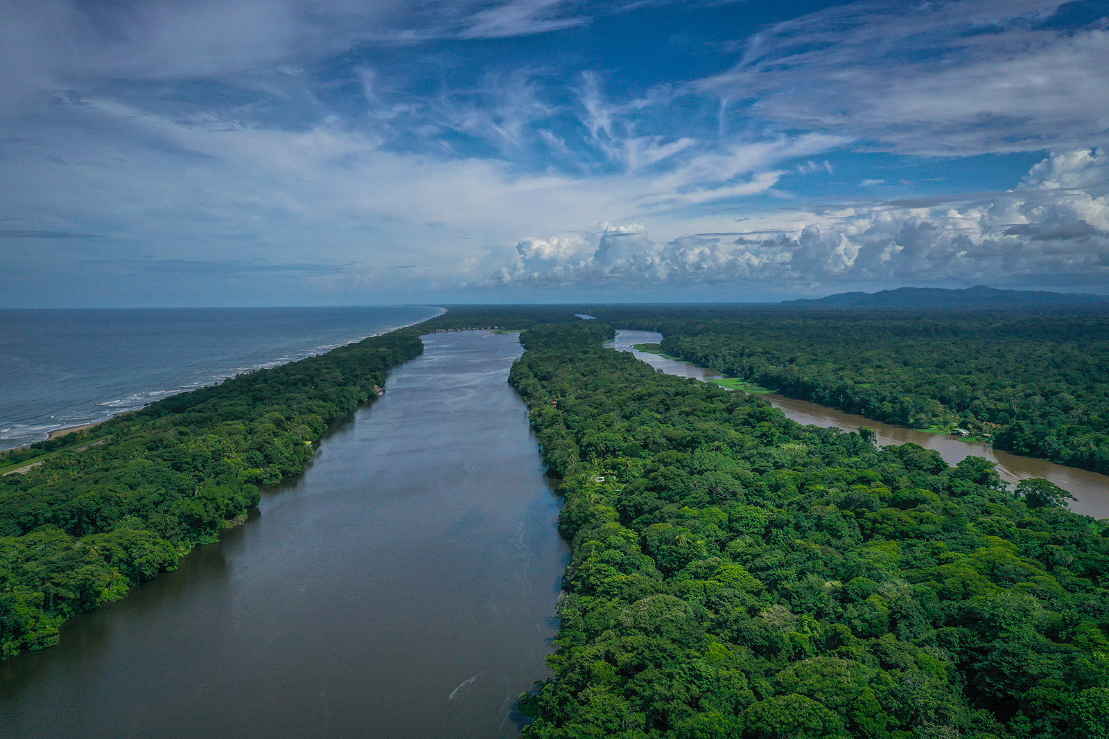

|  |  |  |
| --- | --- | --- |
| BEST SEASON | PRICE | HOW LONG |
| All year | From US $6,100 pp including local flight | 8 Days / 7 Nights |
|  |  |  |

ITINERARY OVERVIEW

Embark on an unforgettable journey through Costa Rica’s majestic landscapes, guided by a private naturalist who brings the country’s rich biodiversity to life. Begin in San José before flying to the remote waterways of Tortuguero, where emerald canals wind through dense jungle teeming with monkeys, sloths, and vibrant birdlife. Explore the village’s conservation efforts and witness nature in its purest form. Travel with your expert guide to Arenal, home to the towering volcano and lush rainforest. Hike to cascading waterfalls, walk ancient lava trails, and unwind in volcanic hot springs. Continue to Manuel Antonio, where pristine beaches meet dense wildlife-filled rainforests. Paddle through the mangrove estuaries of Isla Damas, spot exotic wildlife in Manuel Antonio National Park, or bask in luxury at your beachfront eco-resort. With a seamless blend of adventure and relaxation, this bespoke experience reveals Costa Rica’s most extraordinary wonders through the eyes of an expert, ensuring an unparalleled connection to nature at every step.

**Quick Summary**

B: Breakfast L: Lunch D: Dinner OV: Overnight

|  |  |  |
| --- | --- | --- |
| **Day & Location** | **Transportation, Highlights and Accommodations** | **Meals** |
| Day 1  **San Jose** | Arrival Transfer  **OV: Grano de Oro** |  |
| Day 2  **Tortuguero** | Local flight and boat transfer. Tortuguero Village **OV: Tortuga Lodge and Gardens** | BLD |
| Day 3  **Tortuguero** | Tortuguero National Park and night hike  **OV: Tortuga Lodge and Gardens** | BLD |
| Day 4  **Arenal** | Boat and Land transfer**.** Natural Thermal Pools  **OV: Amor Arenal** | BD |
| Day 5  **Arenal** | La Fortuna Waterfall and Arenal Volcano  **OV: Amor Arenal** | B |
| Day 6  **Manuel Antonio** | Land transfer to Manuel Antonio & Relaxation  **OV: Arenas del Mar** | B |
| Day 7  **Manuel Antonio** | Kayaking at Isla Damas & Custom Beach Adventures  **OV: Arenas del Mar** | B |
| Day 8  **Departure** | Departure, transfer to San Jose International airport | B |

ITINERARY IN DETAIL

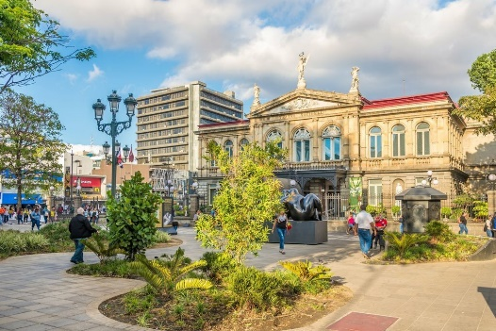**Day 1 | Arrival in San José**

Upon your arrival at Juan Santamaría International Airport, your Costa Rican adventure begins seamlessly. After disembarking, follow the signs to the immigration area where you’ll have your passport checked and stamped. Once through, proceed to the baggage claim area to collect your luggage, with complimentary carts available to assist you. After gathering your bags, pass through customs, placing your luggage on the conveyor belt for X-ray screening and handing over your completed customs form. Once cleared, you’ll exit the terminal, where it’s best to avoid taxi solicitations and instead look for your Green Planet Expeditions driver, who will be waiting to ensure a smooth transfer to your destination. Settle into your luxury accommodation in San José, where you can relax and unwind after your journey, enjoying a restful night before the next day's adventures. Overnight at Grano de Oro

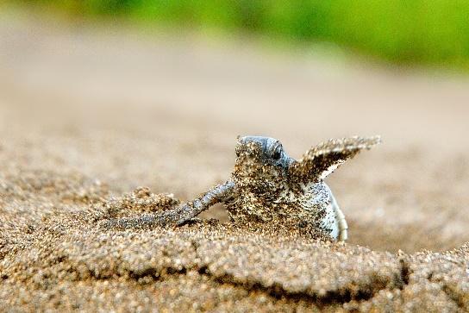**Day 2 | San José to Tortuguero**

After breakfast Your adventure begins as a private driver picks you up at Grano de Oro and transfers you to the local airport for a short scenic flight from San Jose to Tortuguero- The Amazon of Costa Rica offering stunning aerial views of Costa Rica’s lush landscapes. Upon landing, a lodge representative will greet you and take you on a scenic boat ride through the canals of Tortuguero National Park, surrounded by a lush jungle teeming with wildlife. Upon arrival, check into Tortuga Lodge & Gardens, where you’ll enjoy a gourmet lunch before heading on a guided tour of Tortuguero Village. Visit the local school (during the school year), the Sea Turtle Conservancy center, artisan shops, and Afro-Caribbean neighborhoods, learning about the community's transformation from turtle hunting to conservation. Overnight at Tortuga Lodge & Gardens.

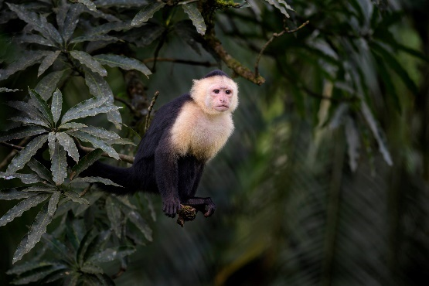**Day 3 | Tortuguero**

Start with an early breakfast at the lodge, then join a three-hour boat tour through Tortuguero National Park with a local naturalist guide. Explore remote creeks and lagoons, observe Howler monkeys, Northern Jacana waterfowl, caimans, and otters. Each tour provides a unique glimpse into the rainforest’s morning activities. In the evening, experience a two-hour guided walk in Tortuga Lodge’s private nature reserve. Equip yourself with rubber boots, a rain poncho, and a flashlight. Dress in long pants, a long-sleeved shirt, and apply insect repellent. Venture into the coastal rainforest to observe nocturnal species and the unique Strawberry Poison Dart Frog. Return to the lodge by 7 p.m. for a delightful dinner. Overnight at **Tortuga Lodge & Gardens.**

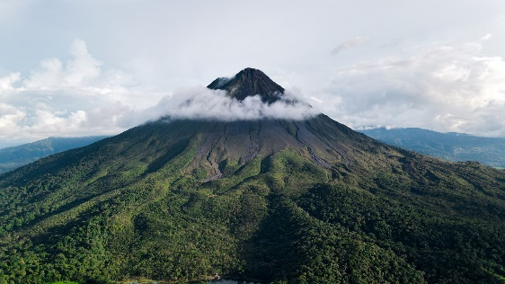**Day 4 | Tortuguero to Arenal**

After breakfast, take a scenic boat transfer back to Caño Blanco Dock, where your exclusive naturalist guide will join you for the remainder of your journey, sharing fascinating insights about Costa Rica’s diverse ecosystems. Your 4.5 to 5-hour drive to Arenal showcases lush jungles, banana plantations, and rolling hills, culminating with the majestic Arenal Volcano on the horizon. Upon arrival at Amor Arenal, settle in and explore the resort’s beautiful trails or relax in its amenities. In the evening, your adventure continues with a visit to Ecotermales Fortuna, renowned for its natural volcanic thermal pools. These rejuvenating pools, heated by the geothermal activity of Arenal Volcano, offer a soothing experience with therapeutic benefits. The warm, mineral-rich waters are ideal for relaxing tired muscles, improving circulation, and promoting overall wellness. Enjoy a delicious dinner at the hot springs, surrounded by lush tropical gardens and illuminated by soft, ambient lighting. Your guide will be on hand to provide insights into the volcanic processes that create these unique thermal features and their health benefits, making for a memorable and enriching evening. Overnight at **Amor Arenal.**

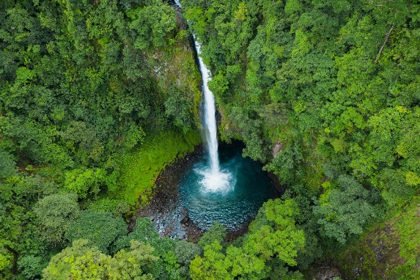**Day 5 | Arenal**

Your day begins with a visit to the iconic **La Fortuna Waterfall,** where your naturalist guide will lead you on a scenic hike through lush rainforest, pointing out native plants and wildlife along the way. As you descend the 500 steps to the base of the waterfall, be mesmerized by the sheer beauty of the 70-meter cascade of water plunging into a turquoise pool below. Once at the base, you can take a refreshing dip in the cool waters surrounded by towering trees and vibrant tropical plants. Your guide will explain the area's fascinating ecology, the river's role in the local ecosystem, and share stories of Costa Rica’s unique biodiversity. After this invigorating experience, you’ll enjoy a **delicious local lunch** at a traditional restaurant, offering you a taste of Costa Rica's rich culinary heritage. Feast on fresh ingredients from the region, from savory plantains to tender meats and farm-to-table vegetables. In the afternoon, your adventure continues with a **guided tour of the Arenal 1968 Lava Flow**, a significant site that showcases the power and beauty of volcanic activity. As you explore the trails of hardened lava from the 1968 eruption, your guide will share captivating stories about Arenal Volcano’s history, including its eruptions, and explain the impact it has had on the surrounding landscape. You’ll learn about the regeneration of the forest, volcanic rock formations, and the rich diversity of plant and animal life that has adapted to this dynamic environment. As you walk along the lava fields, admire panoramic views of Arenal Lake and the impressive volcano looming above. Your naturalist guide will deepen your understanding of the region’s geology and ecosystem, creating a day rich in both adventure and discovery. Return to your hotel in the evening, feeling inspired by the natural beauty and volcanic forces that define Arenal. Overnight at **Amor Arenal.**

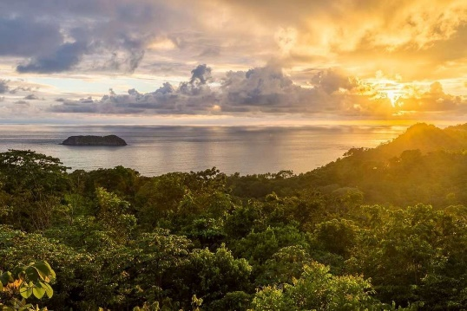**Day 6 | Journey to Manuel Antonio & Relaxation**

Bid farewell to the misty cloud forest as you make your way toward Costa Rica’s breathtaking Pacific Coast. Along the scenic drive to Manuel Antonio, your guide will point out fascinating highlights—from crocodile-inhabited rivers to charming local villages brimming with culture. Upon arrival, check in at Arenas del Mar, an eco-luxury beachfront resort offering direct access to a pristine private beach. Spend your afternoon unwinding by the ocean, exploring the surrounding rainforest trails, or immersing yourself in Manuel Antonio’s vibrant culinary scene. This upscale beach town exudes an enchanting, almost storybook-like ambiance, where tales of tropical escapes come to life. Food and drink play a central role in the local culture, with a diverse gastronomic scene that ranges from traditional Costa Rican staples like gallo pinto, plantains, and fresh seafood to world-class fusion cuisine. As the sun begins to set, indulge in a gourmet seaside dinner with panoramic ocean views, capping off a day of relaxation and indulgence. Overnight at Arenas del Mar.

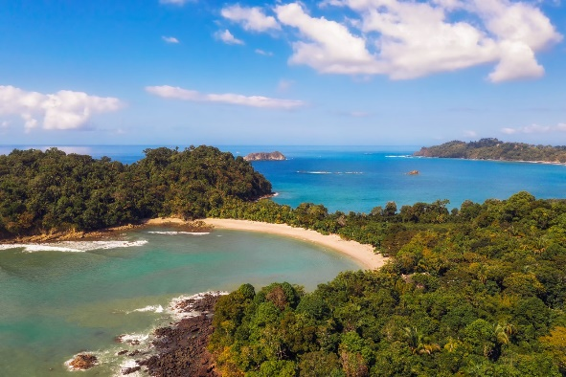**Day 7 | Kayaking at Isla Damas & Custom Beach Adventures**

Today’s included adventure is a kayaking tour through Isla Damas Mangroves, a unique ecosystem teeming with monkeys, sloths, and exotic birds. Paddle through the serene waterways as your guide shares insights into the delicate balance of this coastal habitat. The rest of the day is yours to customize with a variety of options:

* Manuel Antonio National Park: Spot monkeys, iguanas, and sloths along scenic trails leading to pristine beaches.
* Horseback Riding: Explore hidden beaches and jungle trails on a guided horseback adventure.
* Quepos Cultural and Social City Tour
* Night walk in the tropical rainforest
* Leisure Time: Simply relax and soak up the sun at the resort’s private beach.

Your guide will ensure the perfect balance between adventure and relaxation, making the most of your last full day in Costa Rica. Overnight at Arenas del Mar.

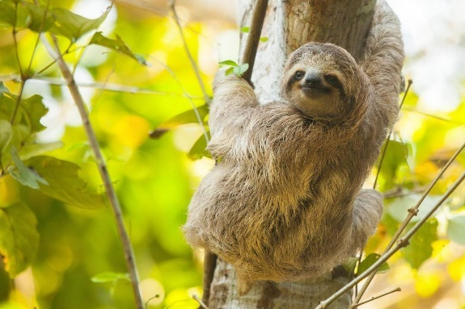**Day 8 | Departure**

On your final day in Costa Rica, your dedicated **naturalist guide** will join you one last time for the journey from **Manuel Antonio** to **San José.** As you travel through the breathtaking scenery of Costa Rica’s diverse landscapes, your guide will share fascinating insights into the regions you pass through—pointing out the transition from the coastal forests to the mountainous terrain, and the agricultural fields of the Central Valley. This scenic 3 to 3.5-hour drive offers a final opportunity to soak in Costa Rica’s natural beauty, with a chance to spot wildlife along the way and reflect on your adventure. Upon arrival at **Juan Santamaría International Airport**, your guide will ensure a smooth drop-off and assist with any last-minute details, leaving you with unforgettable memories of your time exploring Costa Rica's rich biodiversity and landscapes. Be sure to arrive at least three hours before your departure for a seamless and stress-free check-in process. **Safe travels** and we hope to welcome you back to Costa Rica soon!

*Note: To facilitate a seamless connection with your local flight, it is crucial that your international flight departs no earlier than 11:00 a.m. If your international flight is scheduled to depart earlier, we recommend planning an overnight stay in San Jose city on day 8 and departing at your convenience on day 9 to ensure a hassle-free continuation of your journey.*

**Pricing**

|  |  |
| --- | --- |
| **2025** | **Per Adult Sharing double occupancy** |
| Price based on 2 travelers | $6,100 |

This is a preliminary costing; hotels may vary according to availability at time of booking.

**Included**

* Private Car and Naturalist guide from day 4 till day 8
* Tours and activities explicitly listed as included in the itinerary
* Land transfers
* Local flight from San Jose to Tortuguero
* Boat transfers in Tortuguero
* Hotel accommodation as mentioned in the itinerary
* Meals as indicated [B-Breakfast, L-Lunch, D-Dinner]
* Entrance fees to the sites explicitly listed as included in the itinerary
* Permanent assistance during the trip
* Green Planet Expeditions travel consultation and pre-departure services

**Not included**

* International airfares
* Tips and gratuities
* Airport departure taxes
* Drinks, alcoholic beverages, and meals other than listed above.
* Personal expenses for extra services, optional activities, or changes in your itinerary for reasons beyond our control.
* **Mandatory Travel Insurance:** To ensure a smooth travel experience, all participants are required to have a comprehensive travel insurance policy. This policy should include trip cancellation, medical services, and coverage for active adventures or evacuations. “Cancel For Any Reason” (CFAR) coverage is highly recommended to protect your investment in case of unforeseen circumstances.
* Any other items not mentioned above.

ACCOMMODATIONS

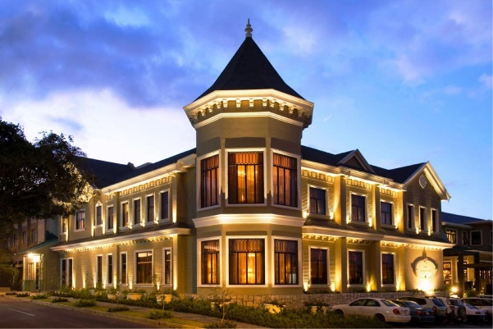**Hotel Grano de Oro**

Hotel Grano de Oro is a charming, boutique hotel nestled in the heart of San José, blending the elegance of a Victorian mansion with modern luxury. The hotel’s intimate atmosphere is complemented by lush tropical gardens, warm wood interiors, and beautifully appointed rooms featuring plush bedding and stylish décor. Guests can unwind in the rooftop Jacuzzi, savor gourmet dishes at the renowned on-site restaurant, or explore nearby cultural attractions. With its blend of old-world charm and contemporary comforts, Hotel Grano de Oro offers a tranquil urban escape with personalized service.

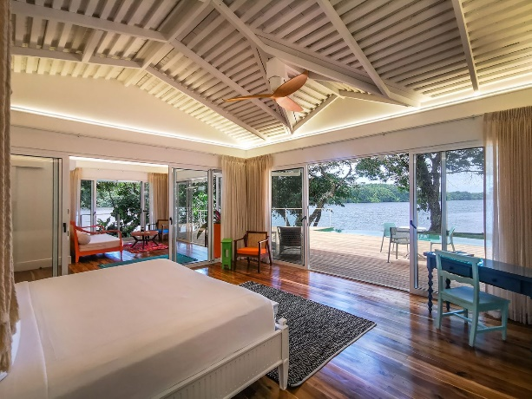**Tortuga Lodge and Gardens**

Tortuga Lodge and Gardens, set on the banks of Tortuguero's scenic canals, offers an immersive jungle experience in one of Costa Rica’s most biodiverse regions. Surrounded by lush rainforest, this eco-friendly lodge features spacious, airy rooms that open to the sights and sounds of nature, with hammocks on private terraces for relaxation. Guests can enjoy guided wildlife tours, boat rides through the national park, or stroll the private trails teeming with exotic flora and fauna. With a focus on sustainability and comfort, Tortuga Lodge provides a serene retreat for nature lovers.

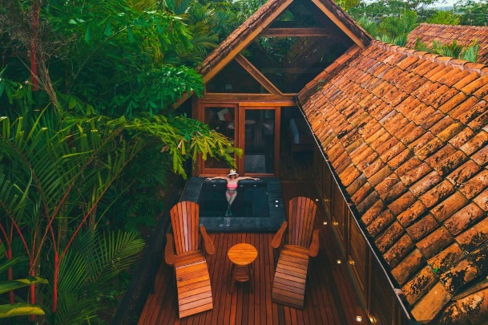**Amor Arenal**

Amor Arenal Hotel, nestled at the edge of a lush rainforest with stunning views of Arenal Volcano, offers a luxurious and intimate connection to nature. Each elegant cabin features private hot spring plunge pools, spacious balconies, and modern amenities like air conditioning and Wi-Fi. Guests can savor farm-to-table gourmet dishes while enjoying panoramic views or indulge in spa treatments and wellness activities such as yoga and guided rainforest hikes. With its eco-friendly practices and convenient location near La Fortuna's attractions, Amor Arenal provides the perfect blend of luxury, adventure, and relaxation in Costa Rica.

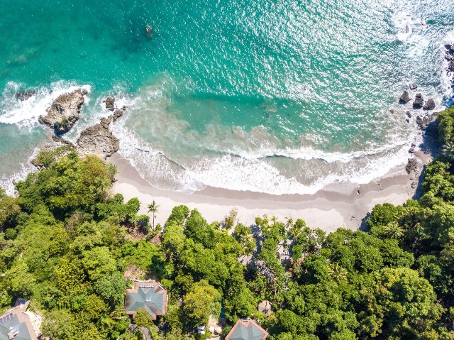**Arenas del Mar**

Arenas del Mar Hotel is a luxury beachfront eco-resort located on the edge of Manuel Antonio National Park. Surrounded by rainforest and offering stunning views of the Pacific Ocean, this boutique hotel combines sustainability with elegance. Guests can enjoy private access to two pristine beaches, spacious suites with ocean or forest views, and an array of activities like wildlife tours, guided nature walks, and water sports. With a focus on personalized service and environmental responsibility, Arenas del Mar provides an idyllic retreat for those seeking both adventure and relaxation in a breathtaking setting

**Booking your Green Planet Expedition**

**How to reserve a trip**

To secure your spot on a trip, you can conveniently book online using our [Reserve a Trip form](https://greenplanetexpeditions.com/reservation-form/)  or by calling **1-800-430-9498**. Your reservation is confirmed upon receipt of the reservation form and the initial 50% trip deposit.

Please note that we are unable to hold space until the deposit is received. If the requested space is unavailable, we will promptly provide alternative options for your consideration (if an upgrade is necessary, higher rates may apply).

**Pre departure service**

Upon receipt of your deposit and completed reservation form, we will email you a comprehensive Predeparture Dossier. This contains important information to help you prepare including immunizations, visas, trip insurance, packing checklist, reading list, maps, cross-cultural information, optional trip extensions, and more. You will receive a final trip email including Final Reminders and local contact information in your destination 2-3 weeks before departure.

**Terms and Conditions**

Green Planet Expeditions has arranged your trip utilizing the travel services of local in-country ground operators who are independent contractors. These local outfitters, lodges, hotels, and other suppliers of your travel services will make every effort to conduct this trip as described in the itinerary; however, it is possible that due to transportation schedule changes, weather, delays, and unforeseeable acts of God, humans or nature, this itinerary may vary from what is described. Participants must assume all risks whether identified in advance or unforeseen. All optional activities are at your own risk. Extra costs due to unexpected changes in your itinerary for reasons beyond our control are not included.

Caring for our planet is integral to our ethos. In alignment with our commitment to sustainability, a carbon emissions mitigation fee is incorporated into all our trips. This fee contributes to environmental initiatives that offset the carbon footprint associated with our journeys, ensuring a positive impact on the destinations we explore. Your safety and peace of mind during the journey is our top priorities. **The purchase of traveler’s insurance is mandatory for all participants, and it must cover trip delays, trip cancellations, baggage, accident, or sickness. In some specific cases like Antarctica, it must cover evacuation.**

All information and services provided are subject to our [Terms and Conditions.](https://greenplanetexpeditions.com/terms-conditions/)

At Green Planet Expeditions, we craft strategically curated journeys that immerse travelers in the finest of nature, culture, and local traditions, always seeking out opportunities for exceptional dining experiences. Our expertise lies in tailor-made trips to destinations where we maintain close relationships with local partners, ensuring flawless execution with the assistance of passionate guides deeply connected to their heritage and committed to its preservation.

We believe that tourism, when harnessed thoughtfully, becomes a powerful catalyst for conservation and community upliftment in the destinations we visit.

**As with any good recipe, our trips are infused with the following flavors:**

* Positive impact on the areas you choose to visit, directly or indirectly.
* Amazing private local guides.
* Lovely small boutique hotels according to your budget.
* Good food, no matter how remote the destination is, we strive to offer good cuisine.
* Our trips frequently include surprises, which often turn out to be the highlight of the journey.
* When open to it, visits to less-known destinations, reserved for the daring few, and engages in intimate and meaningful encounters with locals—a cherished treasure highly valued by discerning travelers, as we have discovered through our years of experience in the industry.

**Still haven’t found what you're looking for?**

We offer a wide range of amazing trips that may not all be listed on our website. Plus, we can custom-build pretty much whatever your heart desires, so let us know what we can do for you. If you have any questions about our expedition cruises, private trips, or just want to talk travel, give us a call at + 1 800- 430 9498 or contact us via email at [travel@greenplanetexpeditions.com](mailto:travel@greenplanetexpeditions.com)