

**Costa Rica**

# **Costa Rica Family Expedition: Volcanoes, Cloud Forests & Beaches**

San Jose – Arenal – Monteverde – Manuel Antonio

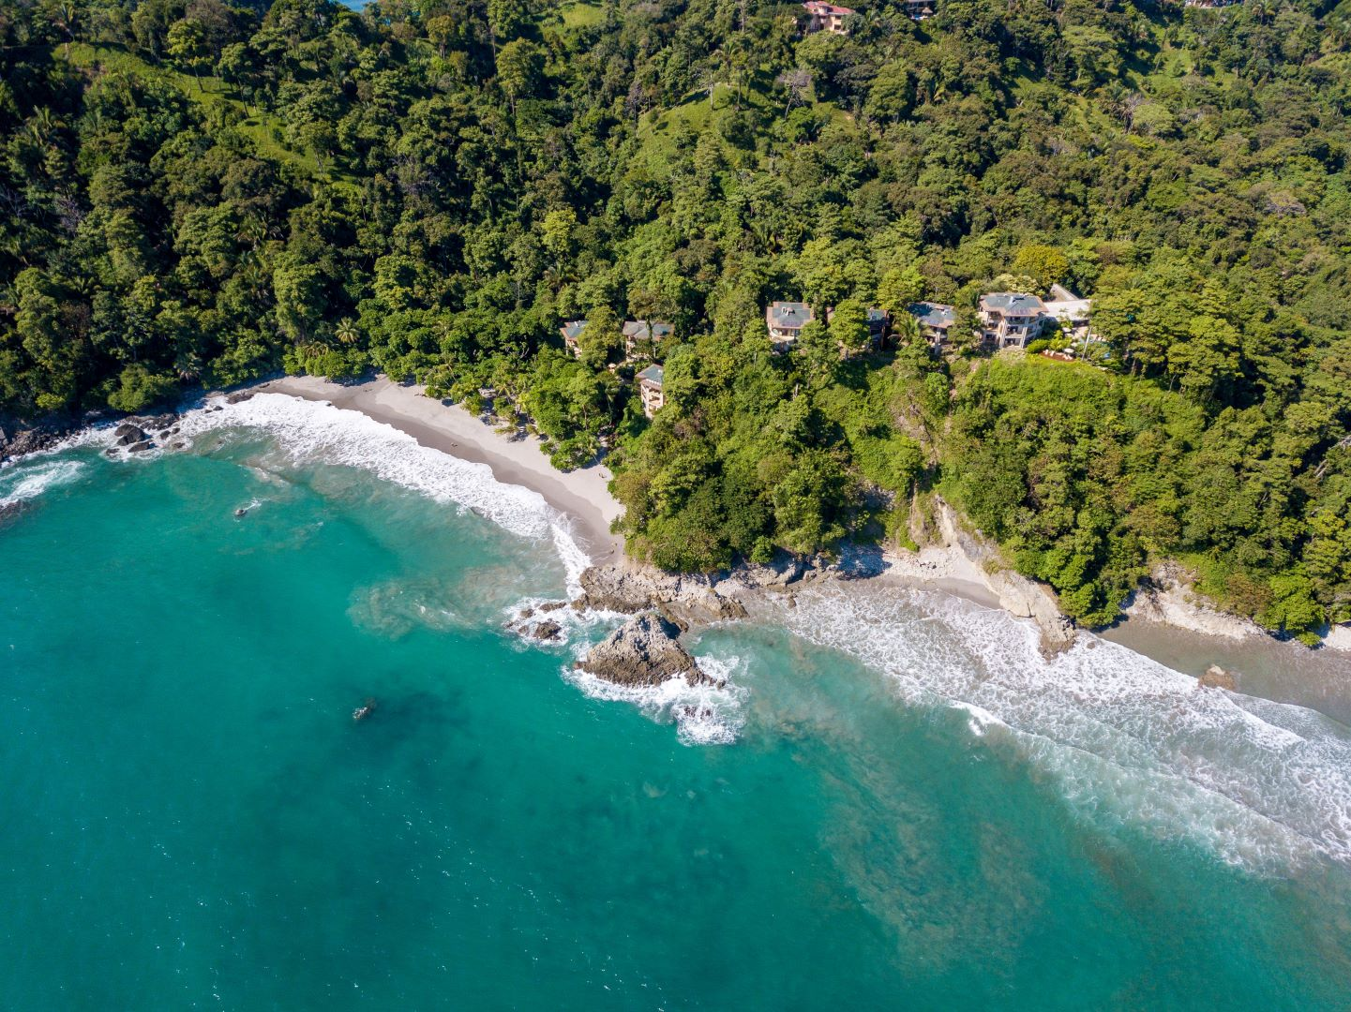

|  |  |  |
| --- | --- | --- |
| BEST SEASON | PRICE | HOW LONG |
| All year | From US $4,300 pp excluding local flights | 8 Days / 7 Nights |
|  |  |  |

ITINERARY OVERVIEW

Embark on an extraordinary family adventure through Costa Rica, where lush rainforests, volcanic landscapes, and pristine beaches set the stage for unforgettable experiences. From the moment you arrive, a private naturalist guide will lead you through hidden trails, vibrant ecosystems, and cultural gems, ensuring a journey filled with wonder. Marvel at Arenal’s towering volcano, soak in natural hot springs, and savor a hands-on Costa Rican cooking class. Traverse the misty Monteverde Cloud Forest, zipline through the treetops, and encounter exotic wildlife on guided nature walks. Then, unwind on the sun-kissed shores of Manuel Antonio, where the jungle meets the sea in a paradise of relaxation and adventure. With luxurious accommodation, seamless logistics, and immersive activities tailored for all ages, this journey blends excitement, discovery, and pure Pura Vida bliss.

**Quick Summary**

B: Breakfast L: Lunch D: Dinner OV: Overnight

|  |  |  |
| --- | --- | --- |
| **Day & Location** | **Transportation, Highlights and Accommodations** | **Meals** |
| Day 1  **San Jose** | Airport Pick up  **OV: Costa Rica Marriott** |  |
| Day 2  **Arenal** | Journey to Arenal & Pura Vida Cooking Class  **OV: Nayara Gardens** | B, L |
| Day 3  **Arenal** | Arenal Custom Adventures  **OV: Nayara Gardens** | B |
| Day 4  **Monteverde** | Scenic Drive to Monteverde & Evening Tour in Children’s Eternal Forest  **OV: Monteverde Lodge and Gardens** | B |
| Day 5 **Monteverde** | Ziplining & Cloud Forest Exploration  **OV: Monteverde Lodge and Gardens** | B |
| Day 6 **Manuel Antonio** | Journey to Manuel Antonio & Relaxation  **OV: Arenas del Mar** | B |
| Day 7  **Manuel Antonio** | Kayaking at Isla Damas & Custom Beach Adventures  **OV: Arenas del Mar** | B |
| Day 8 **Departure** | Departure, transfer to San Jose International airport | B |

ITINERARY IN DETAIL

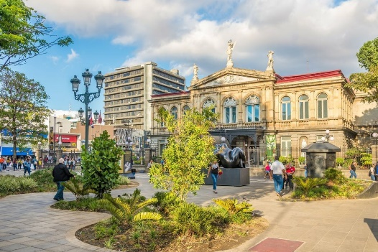**Day 1 | Arrival in San Jose**

Upon arrival at Juan Santamaría International Airport, your family will be warmly greeted by your expert naturalist guide and private chauffeur, who will accompany you throughout your Costa Rican adventure. You'll be transferred in a comfortable, air-conditioned vehicle to the Costa Rica Marriott Hotel, a beautiful colonial-style property surrounded by lush coffee plantations. The hotel offers ample space for relaxation, a refreshing pool, and excellent dining options. Your guide will provide a detailed briefing on your upcoming adventure, offering insights into Costa Rica’s rich biodiversity and cultural heritage. Enjoy a relaxed evening and a delicious dinner at the hotel, preparing for the exciting days ahead. Overnight at Costa Rica Marriott.

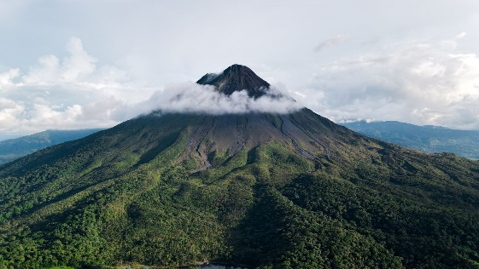**Day 2 | Journey to Arenal & Pura Vida Cooking Class**

After a delicious breakfast, embark on a scenic drive to Arenal, a region renowned for its imposing volcano, lush rainforests, and adventure-filled activities. Along the way, your guide will unveil hidden gems, pointing out wildlife, sharing fascinating stories about the country’s natural history, and revealing secret trails that make Costa Rica extraordinary. Upon arrival at Nayara Gardens, check into your luxurious casita, surrounded by vibrant rainforest and featuring stunning volcano views. In the afternoon, enjoy an immersive Pura Vida Cooking Class, where your family will learn to prepare authentic Costa Rican dishes using fresh local ingredients. Kids and adults alike will love this hands-on experience, guided by expert chefs who will introduce you to the country’s rich culinary traditions. The rest of the day is flexible, and your guide will help you choose between options like relaxing in the thermal hot springs, exploring local trails, or spotting exotic wildlife in the surrounding jungle. Overnight at Nayara Gardens.

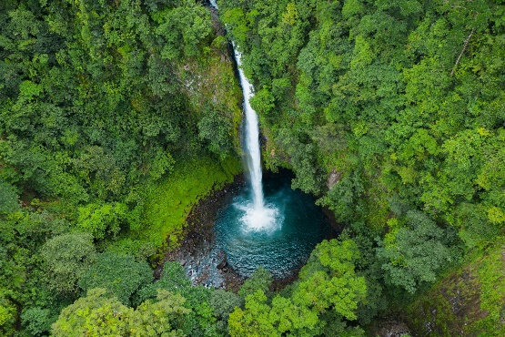**Day 3 | Custom Arenal Adventures**

Your expert naturalist guide will tailor today’s experiences based on your family’s preferences and energy levels. Optional activities, among others:

* Arenal Volcano National Park: Hike through old lava fields and learn about the region’s volcanic history.
* La Fortuna Waterfall: Descend a scenic trail to a stunning 75-meter cascade where you can swim in crystal-clear waters.
* Hanging Bridges Walk: Experience the rainforest from above, spotting monkeys, sloths, and colorful birds.
* Kayaking or Biking: Enjoy an active adventure on Lake Arenal or explore the lush countryside on two wheels.

Throughout the day, your guide’s expertise will elevate each experience, ensuring that you not only see but truly understand the natural wonders around you. Enjoy a relaxing evening at Nayara Gardens, soaking in the hot springs or savoring a gourmet meal. Overnight at Nayara Gardens.

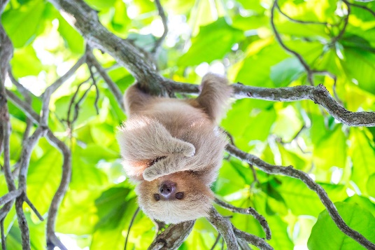**Day 4 | Scenic Drive to Monteverde & Evening Tour in Bosque Eterno de los Niños**

After breakfast, your family will depart the Arenal region and embark on a scenic journey to Monteverde, renowned for its cloud forests and rich biodiversity. The drive takes approximately 3.5 hours, following the winding roads around Lake Arenal before ascending into the misty mountains. Along the way, your guide will share stories of the local culture, point out interesting wildlife, and explain the unique ecosystems that make this area so special. As you climb higher into the mountains, the landscape changes from tropical lowlands to the cooler, lush greenery of the cloud forest. Upon arrival, you’ll check in at Monteverde Lodge & Gardens, a luxurious eco-lodge nestled in the cloud forest. The lodge offers comfortable and spacious family rooms, along with tranquil gardens and a heated pool for your family to enjoy. After some relaxation, your evening will be dedicated to an exclusive experience in the Bosque Eterno de los Niños (Children’s Eternal Forest), the largest private reserve in Costa Rica. This evening tour offers a chance to experience the cloud forest at night, when many of the forest’s creatures become more active. Your expert guide will lead you on a quiet walk through the misty forest, helping you spot nocturnal animals such as frogs, armadillos, tarantulas, and possibly elusive olingo. The Children’s Eternal Forest is known for its incredible biodiversity, and this unique nighttime adventure allows your family to witness the forest’s magical transformation as the sun sets. This tour provides not only a thrilling wildlife experience but also a deeper understanding of the conservation efforts behind this special reserve, which was created through donations from children all around the world. After your night walk, return to Monteverde Lodge & Gardens for a late dinner at the lodge’s restaurant, El Jardín, where you can relax and reflect on the enchanting evening adventure. Overnight at Monteverde Lodge and Gardens.

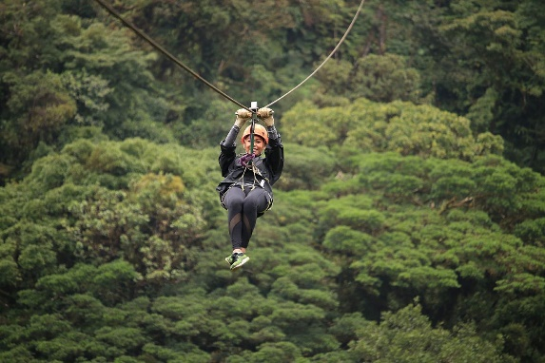**Day 5 | Ziplining & more Cloud Forest Exploration**

Start the day with an adrenaline-pumping zipline adventure at Sky Adventures Monteverde. Your family will soar through the cloud forest canopy, taking in spectacular views of the surrounding mountains and valleys. The children will love the excitement of flying through the treetops, and the experience is a true highlight for thrill-seekers of all ages. After your morning ziplining adventure, enjoy lunch at a local restaurant in the nearby town of Santa Elena. The afternoon offers a variety of options based on your interests:

* Monteverde Cloud Forest Reserve: Hike through one of the most biodiverse ecosystems on the planet.
* The Bat Jungle or Frog Pond: Fascinating experiences perfect for young explorers.
* Coffee & Chocolate Tour: Learn about Costa Rica’s most famous crops in an interactive, family-friendly setting.

Your naturalist guide will help tailor the day to your family’s curiosity, ensuring a rich and immersive experience. Overnight at Monteverde Lodge & Gardens.

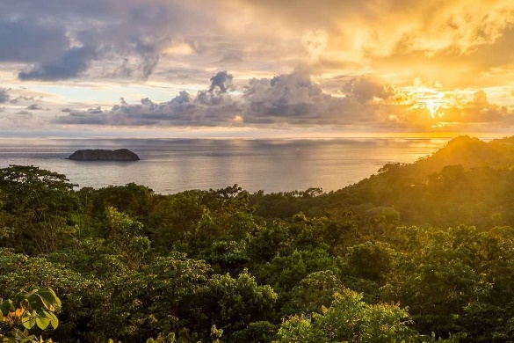**Day 6 | Journey to Manuel Antonio & Relaxation**

Bid farewell to the misty cloud forest as you make your way toward Costa Rica’s breathtaking Pacific Coast. Along the scenic drive to Manuel Antonio, your guide will point out fascinating highlights—from crocodile-inhabited rivers to charming local villages brimming with culture. Upon arrival, check in at Arenas del Mar, an eco-luxury beachfront resort offering direct access to a pristine private beach. Spend your afternoon unwinding by the ocean, exploring the surrounding rainforest trails, or immersing yourself in Manuel Antonio’s vibrant culinary scene. This upscale beach town exudes an enchanting, almost storybook-like ambiance, where tales of tropical escapes come to life. Food and drink play a central role in the local culture, with a diverse gastronomic scene that ranges from traditional Costa Rican staples like gallo pinto, plantains, and fresh seafood to world-class fusion cuisine. As the sun begins to set, indulge in a gourmet seaside dinner with panoramic ocean views, capping off a day of relaxation and indulgence. Overnight at Arenas del Mar.

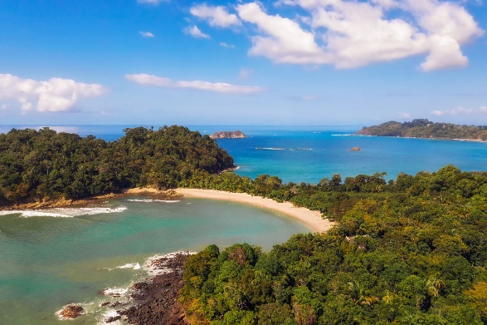**Day 7 | Kayaking at Isla Damas & Custom Beach Adventures**

Today’s included adventure is a kayaking tour through Isla Damas Mangroves, a unique ecosystem teeming with monkeys, sloths, and exotic birds. Paddle through the serene waterways as your guide shares insights into the delicate balance of this coastal habitat. The rest of the day is yours to customize with a variety of options:

* Manuel Antonio National Park: Spot monkeys, iguanas, and sloths along scenic trails leading to pristine beaches.
* Kids Saving the Rainforest: Visit a wildlife rescue center where children can learn about conservation efforts.
* Surf Lessons: Enjoy a fun-filled session with expert instructors on Manuel Antonio’s famous waves.
* Horseback Riding: Explore hidden beaches and jungle trails on a guided horseback adventure.
* Leisure Time: Simply relax and soak up the sun at the resort’s private beach.

Your guide will ensure the perfect balance between adventure and relaxation, making the most of your last full day in Costa Rica. Overnight at Arenas del Mar.

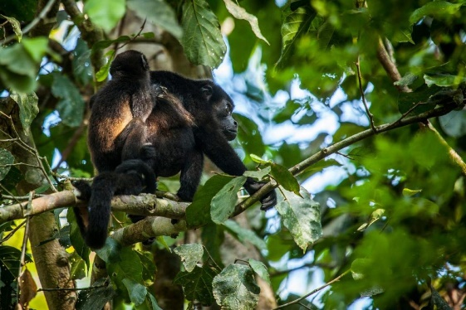**Day 8 | Return to San José and Departure**

After a final breakfast overlooking the ocean, your guide will transfer you back to Juan Santamaría International Airport in San José, a 3-hour drive through scenic coastal and mountain landscapes. for your international flight home. Reflect on a week of unforgettable memories, from ziplining through the cloud forest to kayaking in mangroves and witnessing Costa Rica’s spectacular wildlife up close. Your expert naturalist guide has not only enriched your journey with knowledge and storytelling but also provided access to secret trails, hidden gems, and unique experiences beyond the ordinary. This personalized adventure has given your family a deep appreciation for Costa Rica’s incredible landscapes, wildlife, and culture.

Hasta pronto, Costa Rica!

**Important note:** To facilitate a seamless connection with your local flight, it is crucial that your international flight departs no earlier than 11:00 a.m. If your international flight is scheduled to depart earlier, we recommend planning an overnight stay in San Jose city on day 8 and departing at your convenience on day 9 to ensure a hassle-free continuation of your journey.

**Pricing**

|  |  |  |
| --- | --- | --- |
| **2025** | **Per Adult Sharing double occupancy** | **Per Children (3 to 12)** |
| Price based on 4 travelers | $4,300 | $3,200 |

*This is a preliminary costing; hotels may vary according to availability at time of booking.*

**Included**

* Private Car and Naturalist guide from day 1 till day 8
* Tours and activities explicitly listed as included in the itinerary
* Land transfers
* Hotel accommodation as mentioned in the itinerary
* Meals as indicated [B-Breakfast, L-Lunch, D-Dinner]
* Entrance fees to the sites explicitly listed as included in the itinerary
* Permanent assistance during the trip
* Green Planet Expeditions travel consultation and pre-departure services

**Not included**

* International airfares
* Tips and gratuities
* Airport departure taxes
* Drinks, alcoholic beverages, and meals other than listed above.
* Personal expenses for extra services, optional activities, or changes in your itinerary for reasons beyond our control.
* **Mandatory Travel Insurance:** To ensure a smooth travel experience, all participants are required to have a comprehensive travel insurance policy. This policy should include trip cancellation, medical services, and coverage for active adventures or evacuations. “Cancel For Any Reason” (CFAR) coverage is highly recommended to protect your investment in case of unforeseen circumstances.
* Any other items not mentioned above.

**ACCOMMODATIONS**

**Costa Rica Marriott Hotel Hacienda Belen**

Costa Rica Marriott Hotel is a stunning colonial-style retreat set on a 12-hectare coffee plantation, blending historic charm with modern luxury. The resort features elegant rooms with flat-screen TVs, luxurious toiletries, and select accommodation offering tranquil pool views, all designed for comfort and sophistication. Dining is an elevated experience, with La Isabella offering refined Peruvian-inspired cuisine, Antigua showcasing vibrant Latin American flavors, and the café serving world-class Costa Rican gourmet coffee. Conveniently located just 5 km from Juan Santamaría International Airport, this property offers an unmatched combination of elegance, heritage, and first-class service.

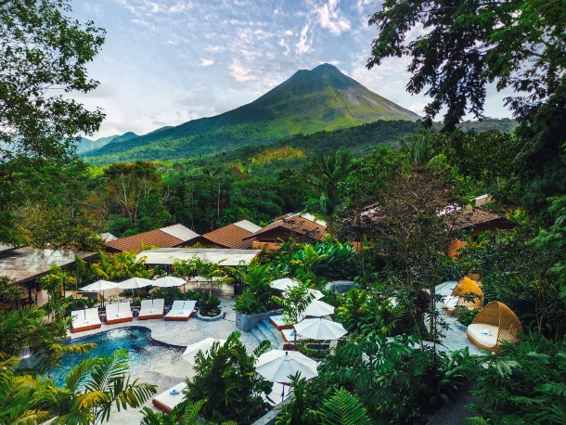**Nayara Gardens**

Nayara Gardens, set against the stunning backdrop of Arenal Volcano, is a sanctuary of tropical luxury. Surrounded by lush rainforests and vibrant gardens, each private casita offers an intimate escape with open-air showers, indulgent terraces, and breathtaking views. Immerse yourself in the natural beauty of Costa Rica, while savoring world-class dining, relaxing in mineral-rich hot springs, and enjoying personalized service that anticipates your every need. At Nayara Gardens, nature and luxury intertwine, creating a magical retreat where every moment feels extraordinary.

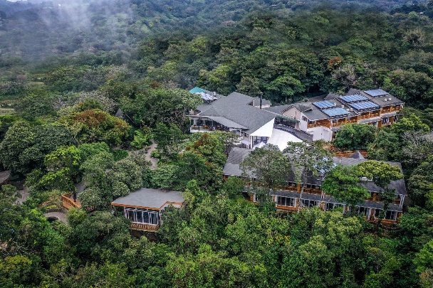**Monteverde Lodge and Gardens**

Monteverde Lodge & Gardens, nestled in Costa Rica's lush cloud forest, offers an enchanting retreat surrounded by nature's tranquility. This eco-lodge features cozy, elegantly designed rooms with large windows that invite in the beauty of the surrounding greenery. Guests can explore the meticulously landscaped gardens, spot wildlife, and relax by the heated outdoor pool. The on-site restaurant serves delicious, locally sourced cuisine, and the lodge’s inviting common areas, like the butterfly garden and fire-warmed lounge, provide serene spaces to unwind. Ideal for nature lovers, it offers easy access to Monteverde’s renowned cloud forest reserves and trails.

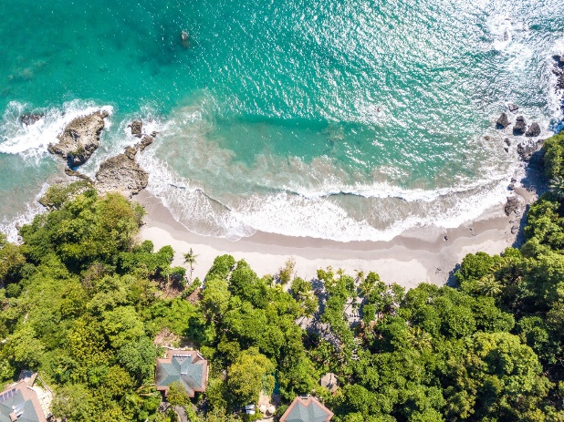**Arenas del Mar**

Perched between lush rainforest and pristine Pacific beaches, Arenas del Mar offers a seamless blend of eco-luxury and natural beauty in Manuel Antonio. This award-winning resort immerses you in the wonders of Costa Rica, with oceanfront suites, direct beach access, and abundant wildlife just steps from your door. Enjoy sustainable luxury with breathtaking views, gourmet dining, and personalized service that elevates every moment. Whether you're lounging by the pool or exploring the vibrant surrounding nature, Arenas del Mar promises an unforgettable escape where the rainforest meets the sea.

**Booking your Green Planet Expedition**

**How to reserve a trip**

To secure your spot on a trip, you can conveniently book online using our [Reserve a Trip form](https://greenplanetexpeditions.com/reservation-form/)  or by calling **1-800-430-9498**. Your reservation is confirmed upon receipt of the reservation form and the initial 50% trip deposit.

Please note that we are unable to hold space until the deposit is received. If the requested space is unavailable, we will promptly provide alternative options for your consideration (if an upgrade is necessary, higher rates may apply).

**Pre departure service**

Upon receipt of your deposit and completed reservation form, we will email you a comprehensive Predeparture Dossier. This contains important information to help you prepare including immunizations, visas, trip insurance, packing checklist, reading list, maps, cross-cultural information, optional trip extensions, and more. You will receive a final trip email including Final Reminders and local contact information in your destination 2-3 weeks before departure.

**Terms and Conditions**

Green Planet Expeditions has arranged your trip utilizing the travel services of local in-country ground operators who are independent contractors. These local outfitters, lodges, hotels, and other suppliers of your travel services will make every effort to conduct this trip as described in the itinerary; however, it is possible that due to transportation schedule changes, weather, delays, and unforeseeable acts of God, humans or nature, this itinerary may vary from what is described. Participants must assume all risks whether identified in advance or unforeseen. All optional activities are at your own risk. Extra costs due to unexpected changes in your itinerary for reasons beyond our control are not included.

Caring for our planet is integral to our ethos. In alignment with our commitment to sustainability, a carbon emissions mitigation fee is incorporated into all our trips. This fee contributes to environmental initiatives that offset the carbon footprint associated with our journeys, ensuring a positive impact on the destinations we explore. Your safety and peace of mind during the journey is our top priorities. **The purchase of traveler’s insurance is mandatory for all participants, and it must cover trip delays, trip cancellations, baggage, accident, or sickness. In some specific cases like Antarctica, it must cover evacuation.**

All information and services provided are subject to our [Terms and Conditions.](https://greenplanetexpeditions.com/terms-conditions/)

At Green Planet Expeditions, we craft strategically curated journeys that immerse travelers in the finest of nature, culture, and local traditions, always seeking out opportunities for exceptional dining experiences. Our expertise lies in tailor-made trips to destinations where we maintain close relationships with local partners, ensuring flawless execution with the assistance of passionate guides deeply connected to their heritage and committed to its preservation.

We believe that tourism, when harnessed thoughtfully, becomes a powerful catalyst for conservation and community upliftment in the destinations we visit.

**As with any good recipe, our trips are infused with the following flavors:**

* Positive impact on the areas you choose to visit, directly or indirectly.
* Amazing private local guides.
* Lovely small boutique hotels according to your budget.
* Good food, no matter how remote the destination is, we strive to offer good cuisine.
* Our trips frequently include surprises, which often turn out to be the highlight of the journey.
* When open to it, visits to less-known destinations, reserved for the daring few, and engages in intimate and meaningful encounters with locals—a cherished treasure highly valued by discerning travelers, as we have discovered through our years of experience in the industry.

**Still haven’t found what you're looking for?**

We offer a wide range of amazing trips that may not all be listed on our website. Plus, we can custom-build pretty much whatever your heart desires, so let us know what we can do for you. If you have any questions about our expedition cruises, private trips, or just want to talk travel, give us a call at + 1 800- 430 9498 or contact us via email at [travel@greenplanetexpeditions.com](mailto:travel@greenplanetexpeditions.com)